LAB PROJECT
PROJECT 2

Course Title: Software Construction and Evolution
Course Name: ESOF-0154L/5232L-W1 - Lab for ESOF 5232

Instructor Name: Prof. Ayman Diyab
Teaching Assistant: Chris Silver

Author Name: Priyam Sheth (1233198)
Report Submitted on: 24/03/2024

Department of Electrical & Computer Engineering
Lakehead University
Table of Contents
OBJECTIVE 2
INTRODUCTION 2
IMPLEMENTATION 2
1. Weather Application 2
Results 4
API Used 7
Issues 7
Black Box Testing 8
2. To-Do Application 13
Results 14
Issues 17
3. Quiz Application 18
Results 19
Issues 21
CONCLUSION 21

OBJECTIVE
To develop three different applications using Java and JavaFX.
- Weather Application
- To-do Application
- Quiz Application

INTRODUCTION
Using various concepts discuss in the class, we were tasked to implement the three different application using Java and JavaFX. The GUI will be developed in JavaFX using Scenebuilder Application and its logic will be implemented in Java.

IMPLEMENTATION

Weather Application
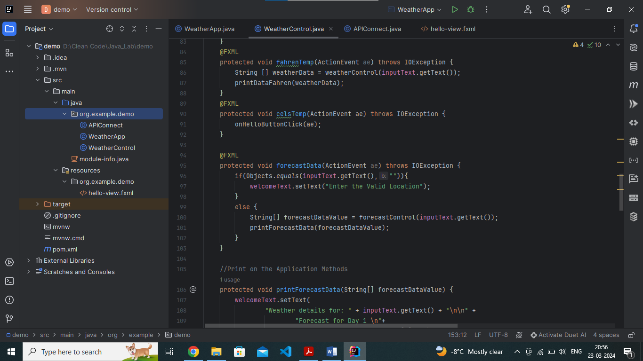
I had created three different classes: weatherApp, weatherControl, and APIConnect. The GUI was developed using Scenebuilder and FXML (hello-view.fxml). I had used JSON to fetch data from the API. I used weatherAPI.com’s API’s to fetch weather data.
weatherApp – It contains the main() method, which will help launch the application by using an FXML file as a resource.
weatherControl – It contains various classes and methods that will help fetch data from the API and get the current and forecast weather details. It helps in maintaining the events of the button and also prints the weather data in the application. It helps in handling the error as well.
APIConnect – It contains the method that has the API URL, which is used to fetch the data. It will also help in formatting the data, which can be important for parsing that data into different classes in Java.
FXML File – It contains the graphical user interface in terms of code.

Results
- Start of an Application:
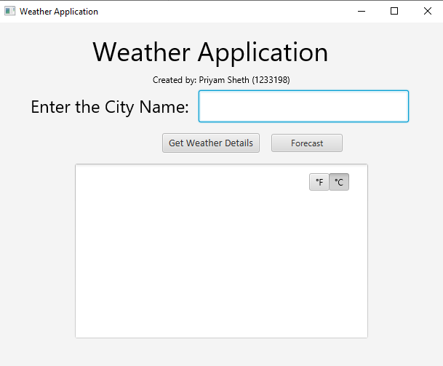
- Invalid Location/Null Location:
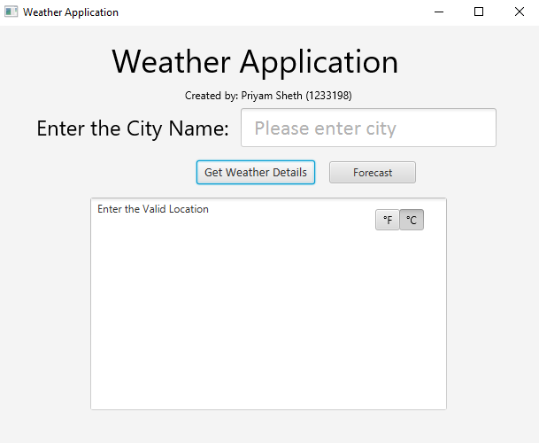
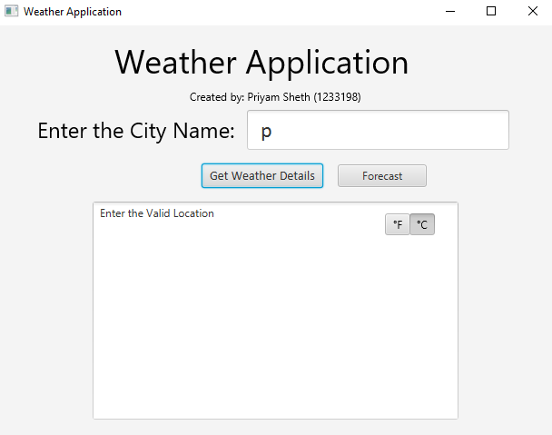
- Current Weather Details:
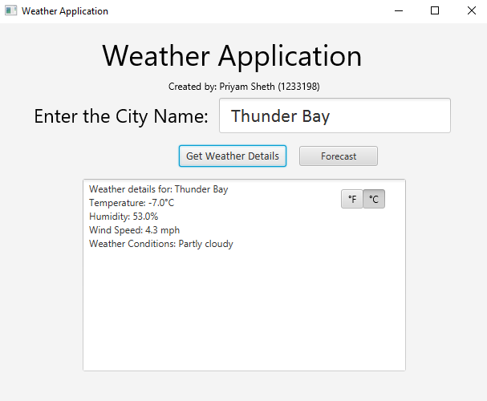

- Forecast Weather Details:
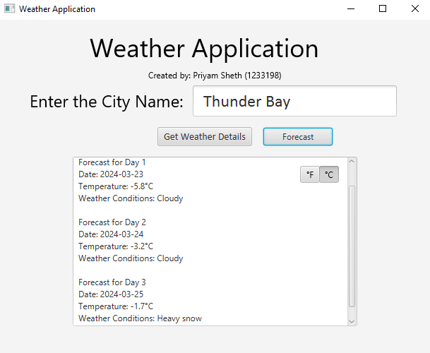
- Unit Conversion:
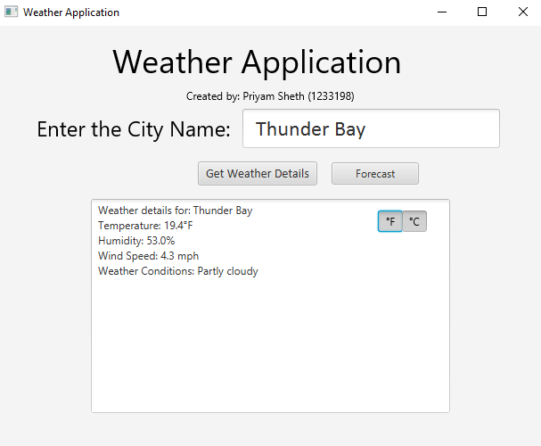

API Used
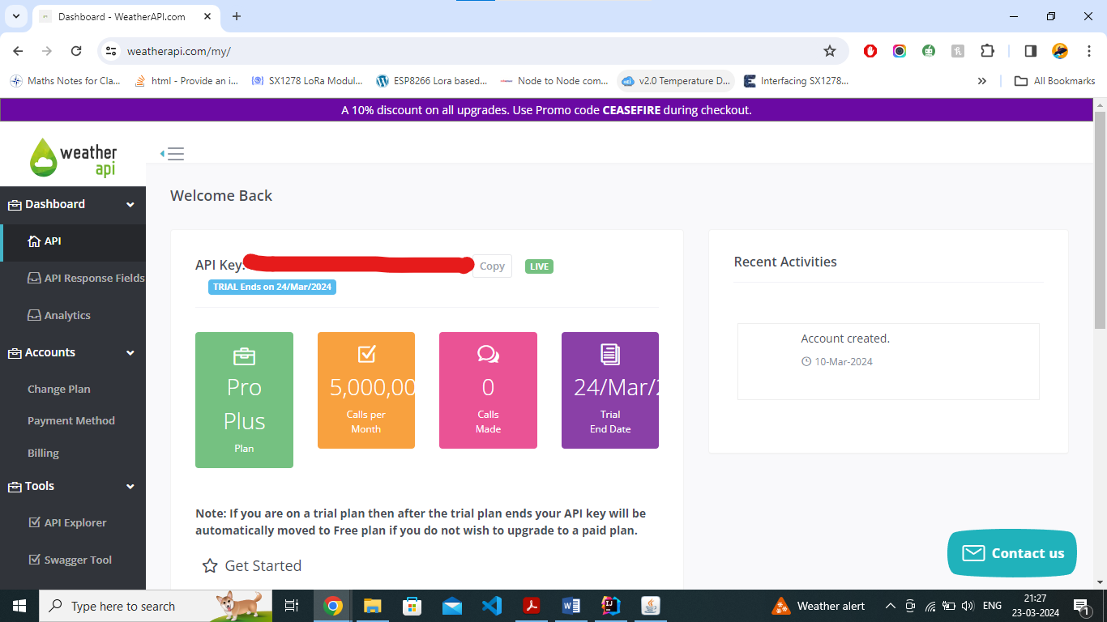

Issues
- Finding the Weather API as most of the API services are paid or either available for minimum amount of days.
- Weather API data is available in JSON and using that in Java need some research
- Finding an API as per our requirement.

Black Box Testing
Test Case 1: Valid Location Search
Description: Verify that the weather application can retrieve weather information for a valid location.
Test Steps:
- Launch the weather application.
- Enter a valid location (e.g., "Thunder Bay") in the search bar.
- Click on the search or submit button.
Expected Output:
The application should display the current weather conditions (temperature, humidity, wind speed, and weather conditions) for the specified location. The displayed information should be accurate and up-to-date.
Real Output:
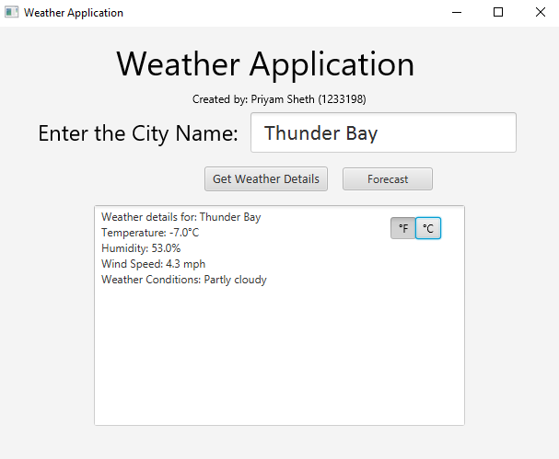
Test Case 2: Invalid Location Search
Description: Verify that the weather application handles invalid location searches gracefully.
Test Steps:
- Launch the weather application.
- Enter an invalid location (e.g., “p”) in the search bar.
- Click on the search or submit button.
Expected Output:
The application should display an error message indicating that the entered location is invalid or not found.
The user should be prompted to enter a valid location.
Real Output:
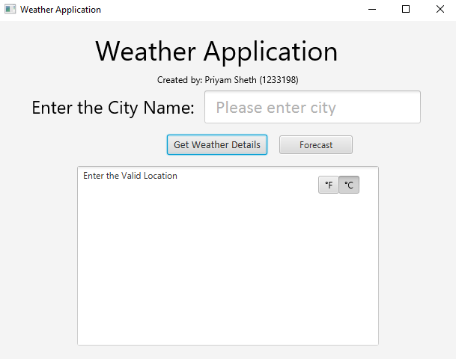
Test Case 3: Temperature Unit Conversion
Description: Verify that the weather application supports temperature unit conversion.
Test Steps:
- Launch the weather application.
- Check if the application provides an option to switch between different temperature units (Celsius and Fahrenheit).
- Toggle the temperature unit setting to another unit.
Expected Output:
The application should update the displayed temperature values to the selected unit (e.g., from Celsius to Fahrenheit or vice versa).
The conversion should be accurate and consistent across all temperature readings.
Real Output:
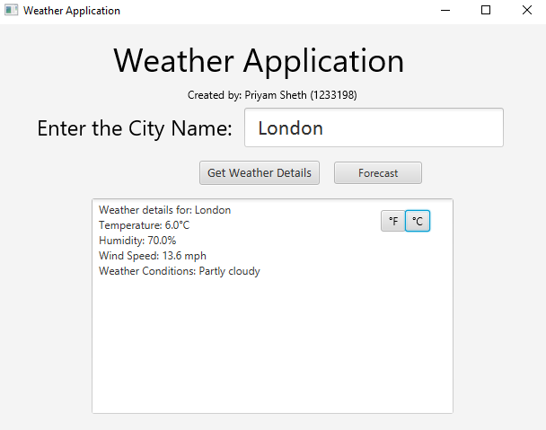
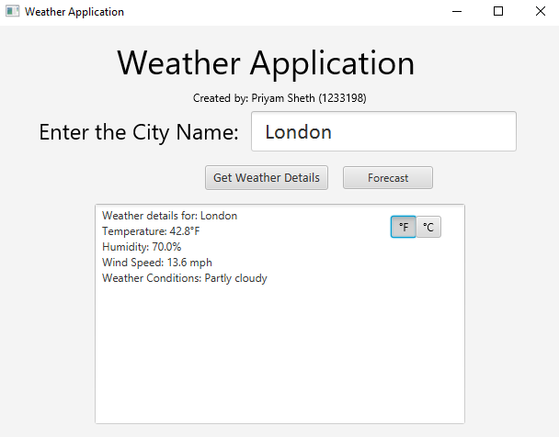

Test Case 4: 3-Day Forecast
Description: Verify that the weather application provides a 3-Day forecast for the selected location.
Test Steps:
- Launch the weather application.
- Select a location and view the weather forecast.
- Check if the application displays a 3-Day Forecast with weather details such as temperature and weather conditions.
Expected Output:
The application should present a 3-Day forecast with accurate weather predictions.
The forecast should include relevant details such as temperature and weather conditions.
Real Output:
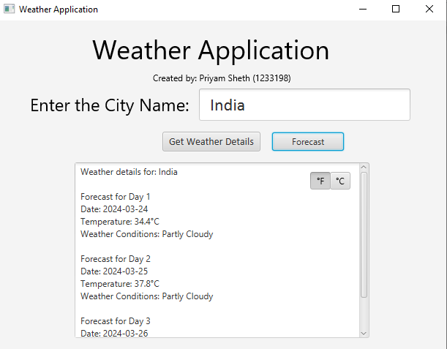

To-Do Application
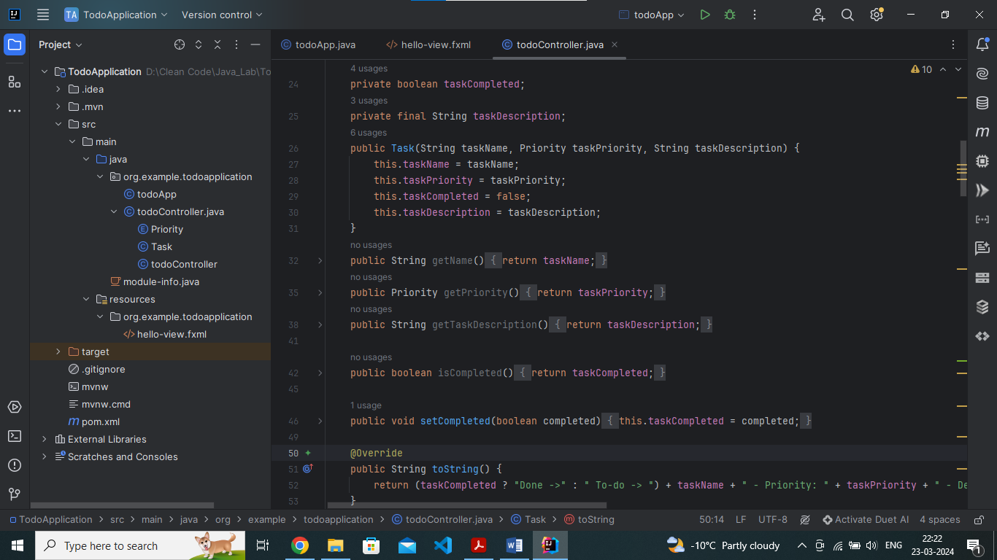
I had created two classes: todoApp and todoController. The GUI was developed using Scenebuilder and FXML (hello-view.fxml).
todoApp – It contains the main() method, which will help launch the application by using an FXML file as a resource.
todoController – It contains an enum Priority which sets the priority of the task such as high, medium, or low. It has a task class that takes taskName, taskPriority and taskDescription as parameters. In this way, we can set the task as complete as well. It also contains buttons with events such as add task, remove task, delete task, update task, and mark as complete task.
FXML File – It contains the graphical user interface in terms of code.

Results
- Start of an Application
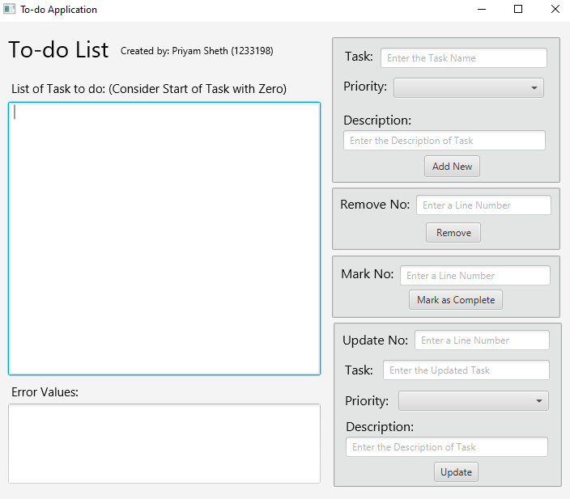
- Null Values
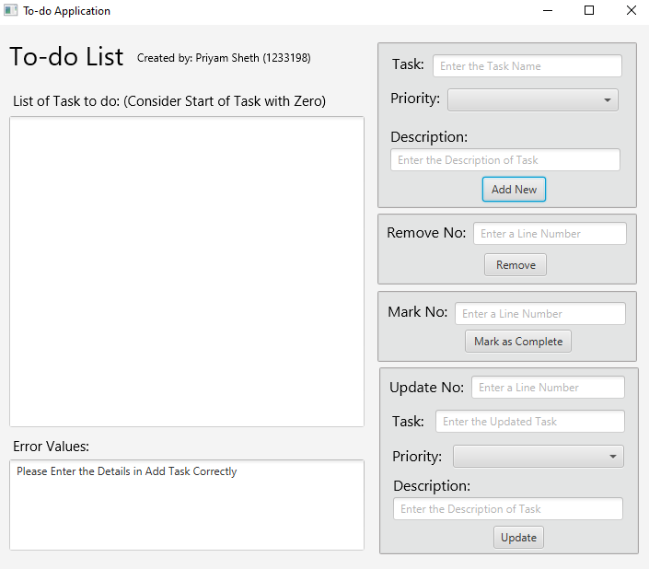
- Range of Task out of Length
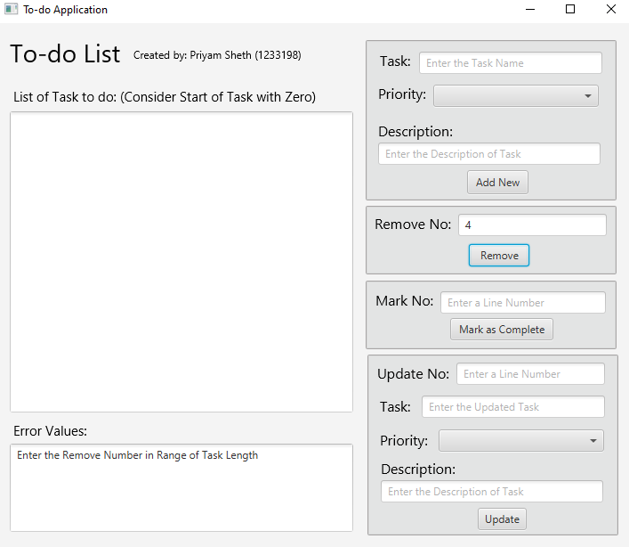
- Add Task
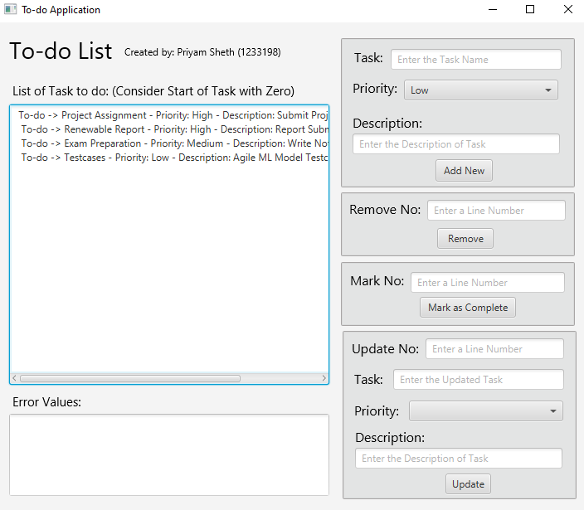
- Remove Task
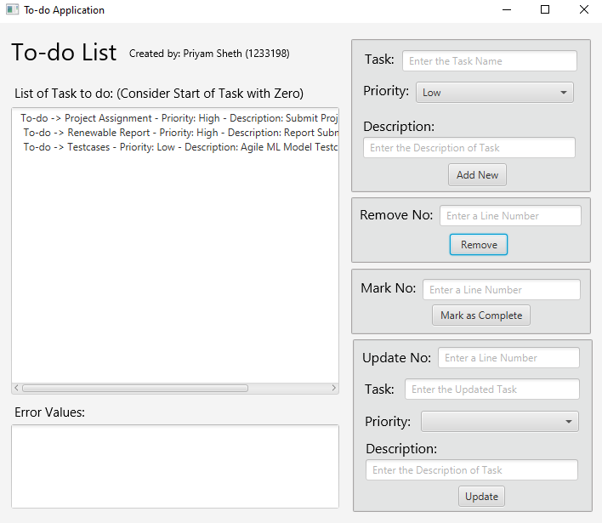
- Mark as Complete
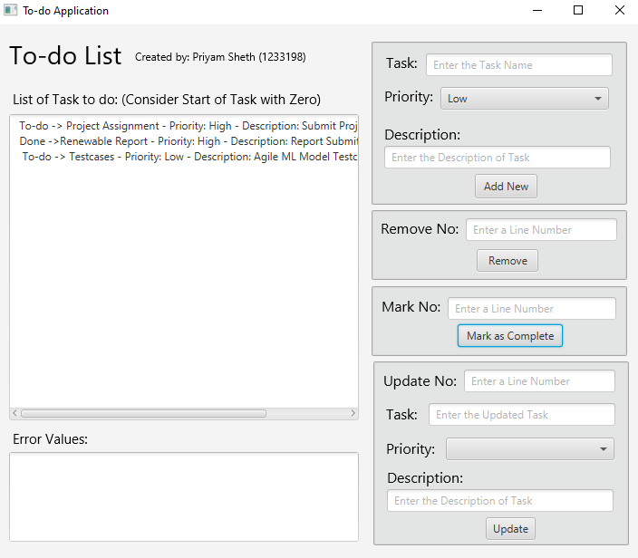
- Update the Task
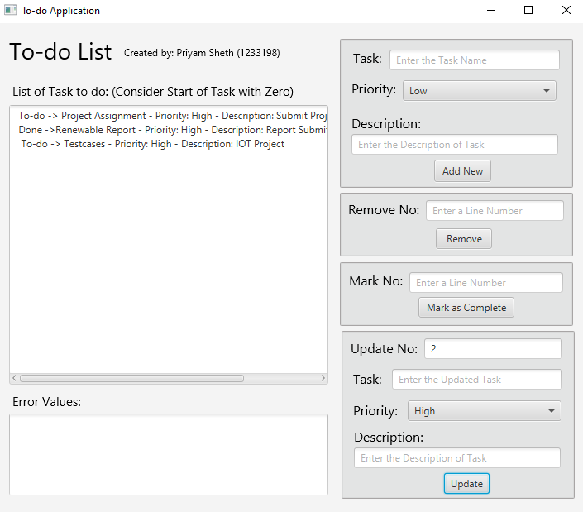

Issues
- Challenge in updating the values in the task.
- Handling the array list and values for the task.

Quiz Application
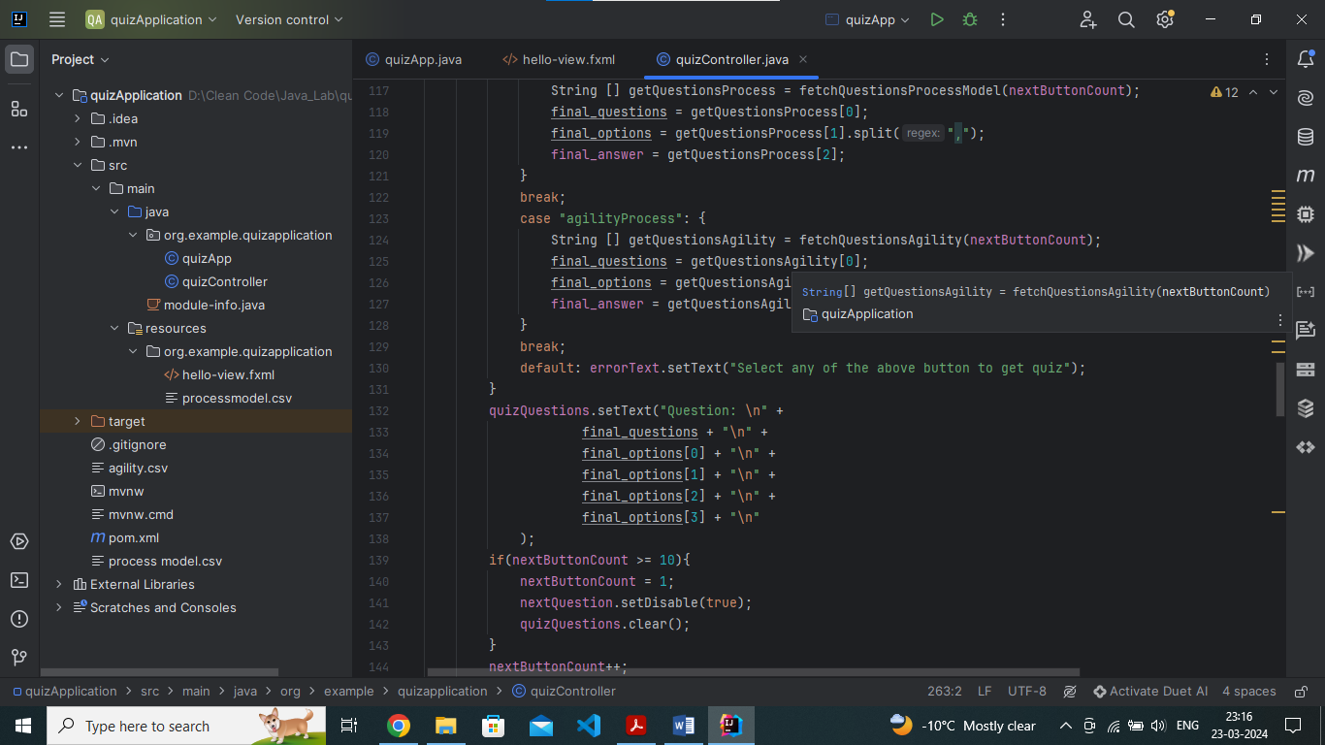
I had created two classes: quizApp and quizController. The GUI was developed using Scenebuilder and FXML (hello-view.fxml).
quizApp – It contains the main() method, which will help launch the application by using an FXML file as a resource.
quizController – It contains the various methods that help in fetching questions from a CSV file for Process Models and Agility. Methods that can show questions and options, update the score as per user inputs, and provide a quiz summary at the end of the quiz.
FXML File – It contains the graphical user interface in terms of code.

Results
- Start of an Application
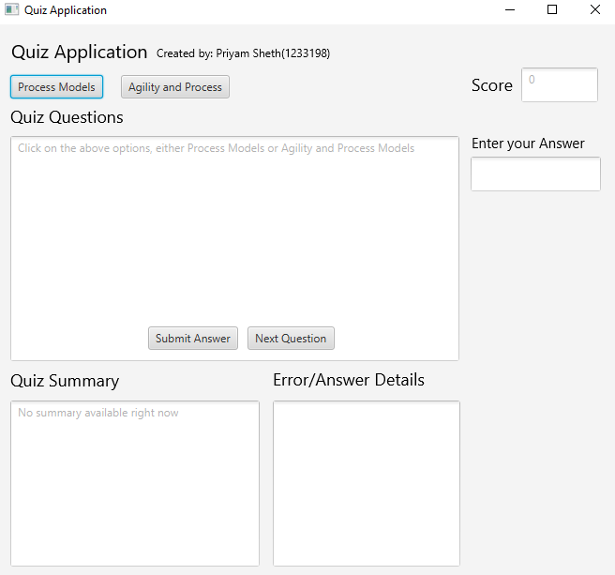
- Process Model Questions
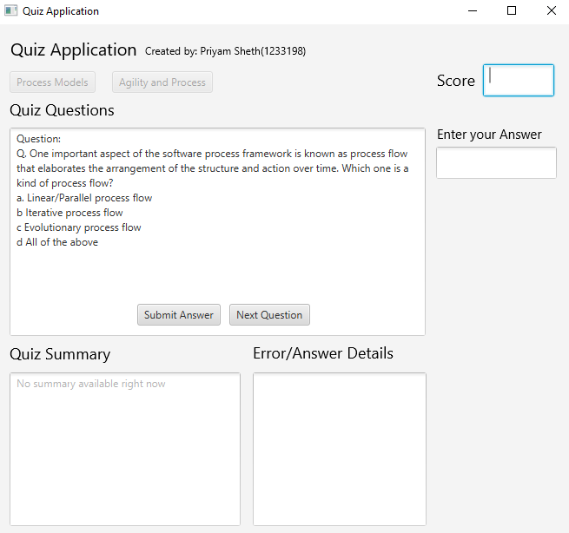
- Score Update and Feedback Details
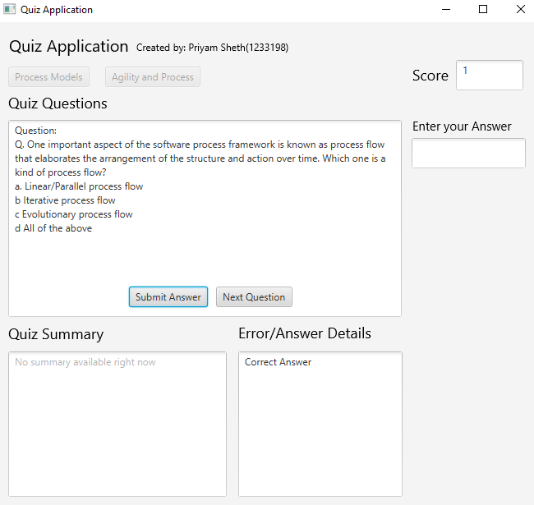
- Quiz Summary
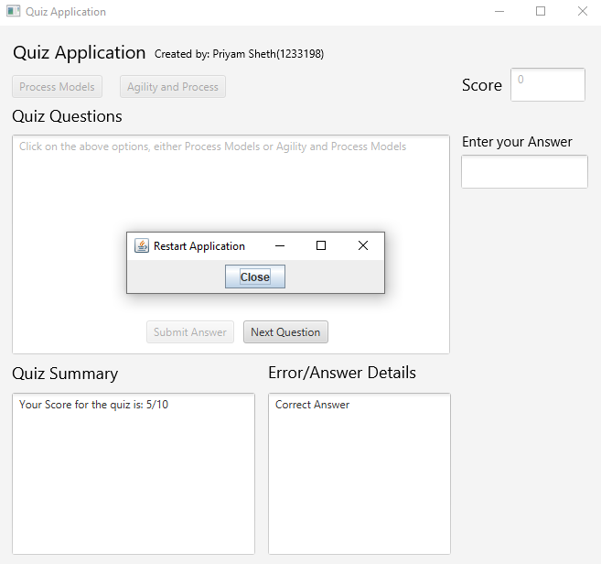
- Agility Process
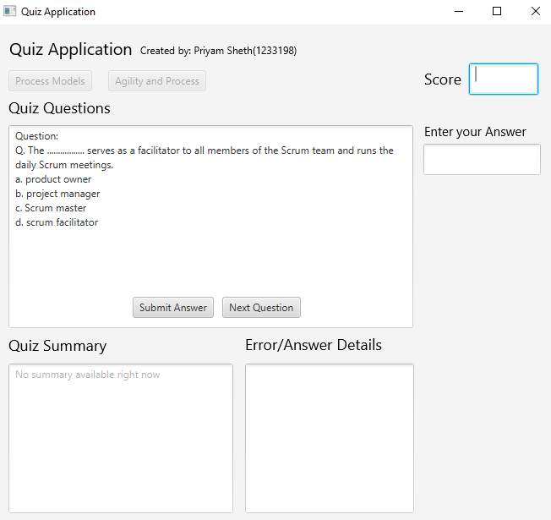

Issues
- Working CSV file and formatting the CSV data.
- Fetching questions from a CSV file.
- Submitting the answer and updating the values for the user.

CONCLUSION
In conclusion, these projects help in learning Java and JavaFX in depth creating a stronger impact towards building the base for application development.

